Private deployment operation documentation
1. Introduction to private deployment
Refers to a cloud built for standalone use, providing the most effective control over data security and
service quality. Private clouds can be deployed within the firewall of an enterprise data center, or they
can be deployed in a secure hosting location. The core of a private cloud refers to a proprietary
resource of an enterprise. A private cloud can be owned, managed, and operated by the organization, a
third party, or both.
Deployment form: online privatization, intranet server.
Deployment content: database, application, middleware, etc.
Advantages: The core of private deployment is that it is more user-friendly than cloud solutions.
• More flexible functions, more mature management mode, support for enterprise customization
• Higher security, the system is deployed locally, and the data is more secure and controllable
• Strong scalability, enterprises can independently develop secondary
• Can achieve internal and external network isolation, LAN + external network office to play a
comprehensive advantage
2. Configuration requirements
Recommended configuration:
CPU: 8 threads 2.7 GHz+
Memory: 64GB
Hard disk: 1TB SSD
OS: Ubuntu 22.04
Corresponding version:
Chassis: 2.10.3+
py: 1.3.38+
Baseline app: 370+
Tablet app: 1.5.8+
Factory tool: 1.0.48+
3. Server Address
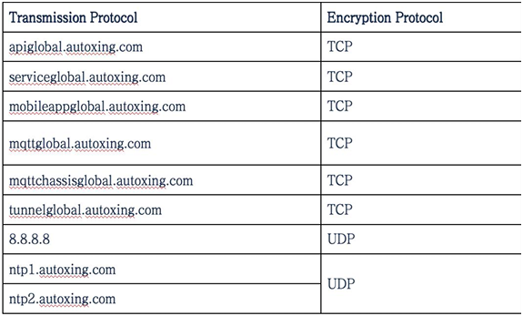
5.Private deployment operation process
Privatization box side
1. Plug the power cord into the power port of the privatization box.
2. Connect the router and the privatization box with an Ethernet cable and connect to the ETH0 interface.
3. Press the power button to turn on the machine.
4. Connect the PC to the ETH1 interface using an Ethernet cable and visit: http://192.168.9.1:9608/ to view the IP address of the privatization box
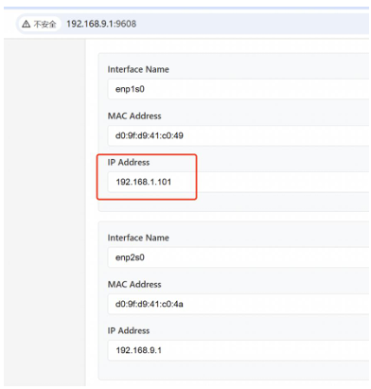
PC network connection
1. Connect to the local area network via Ethernet or WiFi
2. Configure hosts
Directory: C:\Windows\System32\drivers\etc
File: hosts
Modify hosts to:
192.168.1.101 servicelocal.autoxing.com
192.168.1.101 apilocal.autoxing.com
192.168.1.101 mobileapplocal.autoxing.com
192.168.1.101 mqttlocal.autoxing.com
*Note: The IP address must be replaced with the IP address obtained by visiting http://192.168.9.1:9608/
3. Browser certificate installation
Reference steps: Take Chrome as an example, Settings > Privacy and Security > Security > Manage Device
Certificates > Import > Next, select ca.crt, Next, Certificate storage location: Trusted Root Certification
Authorities > Follow the prompts > After completion, restart the browser to verify.
4. Visit https://servicelocal.autoxing.com/admin/; Account: admin Password: 0s^w9j3v
*Note: Currently, a maximum of 20 ordinary accounts are provided. To avoid leaking the password of an
over-managed account, please contact the administrator to obtain it.
Robot side
1. Enter the factory detection tool
Enter the robot settings page, click "Developer Debug" at the bottom of the left menu bar; enter the
password "*#*#9569".
2. Switch service access point
Select privatization and enter the correct access point. Default https://apilocal.autoxing.com
3. Privatization configuration
Enter the server IP in "Privatization Configuration IP"
*Note: The IP needs to be replaced with the IP obtained by visiting http://192.168.9.1:9608/
Click one-click privatization configuration and wait for the configuration to complete.
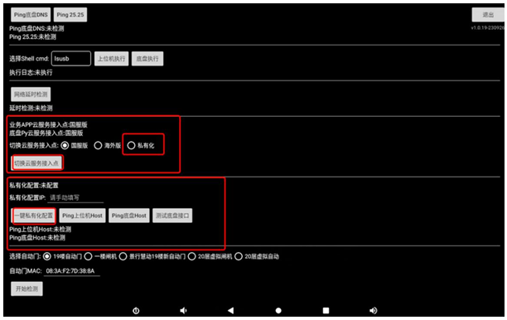
PADside
Operation steps:
1. Enter the settings page
Select "privatization" for APP connection mode
Enter the server i ip
Click Save
Click the verification address, prompt: Verification service address passed
2. Return to the login page
Select "offline connection"
Select the machine to connect to
Enter the machine setting details page
Service settings-cloud service access point: select privatization, enter the server ip, and click one-click privatization configuration
After 30 seconds, check the cloud service platform and the machine is online

